**Product Sales – A Case Study using Power BI**

1. **Load the excel data onto Power BI.**

Done

1. **Transform the data to remove any blank items or errors from columns & close & apply.**

Did all this with the data.

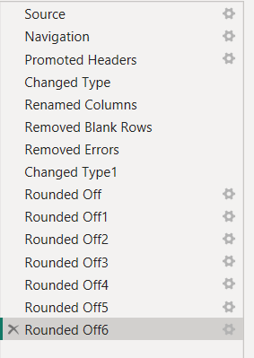

1. **Create a Tree Map Visual containing the data of country & sales and mark the Top 3 countries (using the Top N filters) having the highest sales using the colours Blue, Red, and Green.**

There were two sales columns: NetSales and Sales.

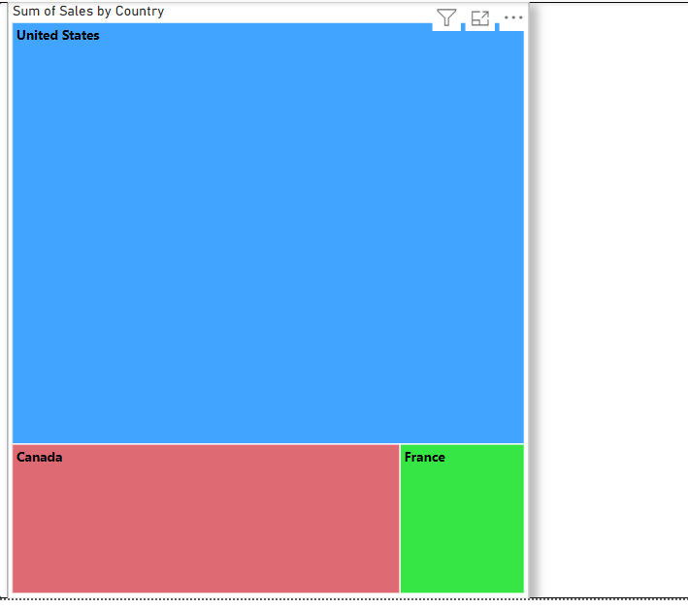

1. **Customise this visual to make it better using the ‘Format your Visual’ option.**
2. **Create another visual - a Gauge visual with the average standard cost and give it the colour Blue.**
3. **Customise & format the visual to make it better.**
4. **Create a ‘funnel’ visual using the data of Product category & Sales.**
5. **Change the colour of the highest selling product to Red.**
6. **You can customise the visual to make it better.**
7. **Create a line graph between order quantity and total discount amount. See if there’s any correlation between the two quantities.**
8. **Customise and format all the charts into a dashboard with a common colour theme and font.**